Exercise 7.8

1. Multiplicative seasonality is required for this series because sales increase towards the end of the graph (2015). Multiplicative seasonality grows and expands as the time series grows and expands
2. A graph of both Holt’s method and Damped Holt’s method
   1. 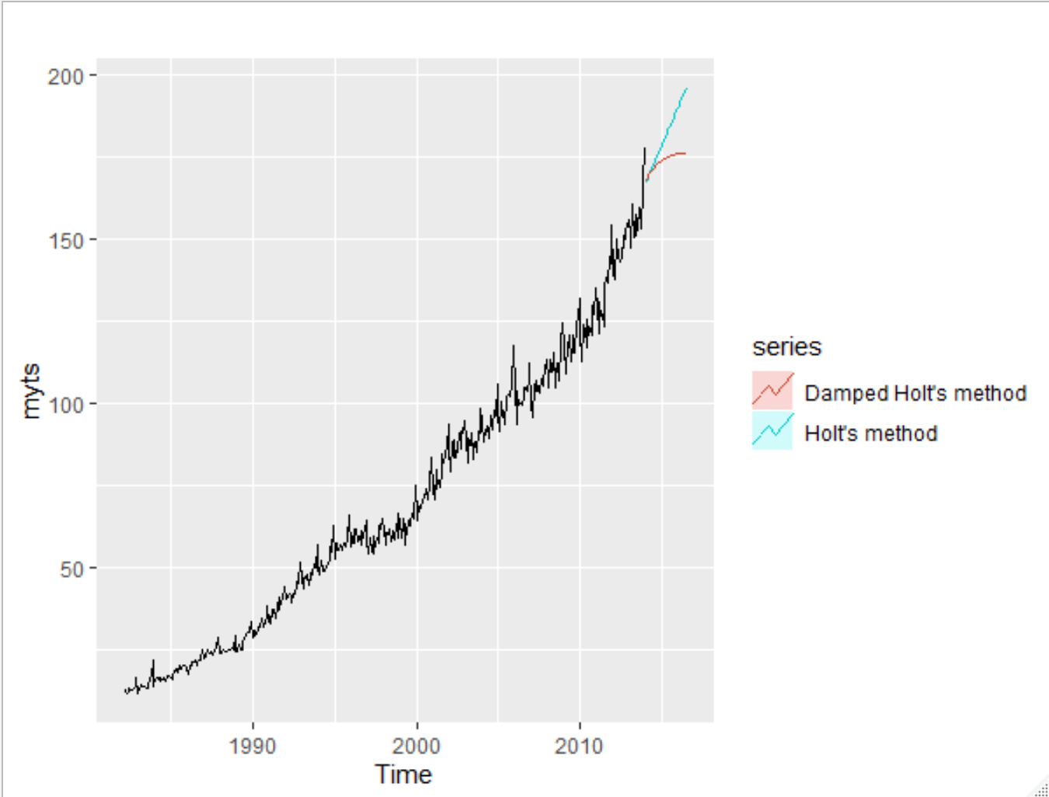
3. The RMSE for each of the methods are as follows
   1. One-step SES – 3.98 RMSE
   2. Holt’s – 3.79 RMSE
   3. Damped Holt’s – 3.92 RMSE
   4. Holt’s methods appears to have the more accurate results according to the RMSE
4. Check residuals
   1. 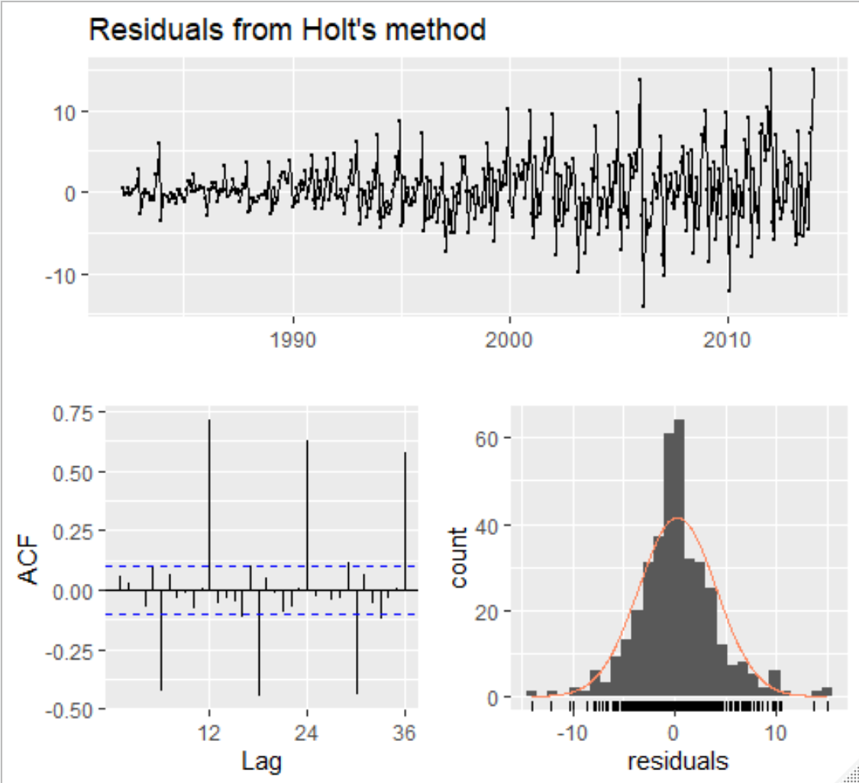
5. The accuracy for the previous test according to the RMSE was 3.79 and the accuracy for the seasonal naïve test was 5.04

Exercise 7.9

I struggled to be able to answer this question as I can not figure out how to perform and STL transformation on a Box-Cox plot

Exercise 7.10

1. 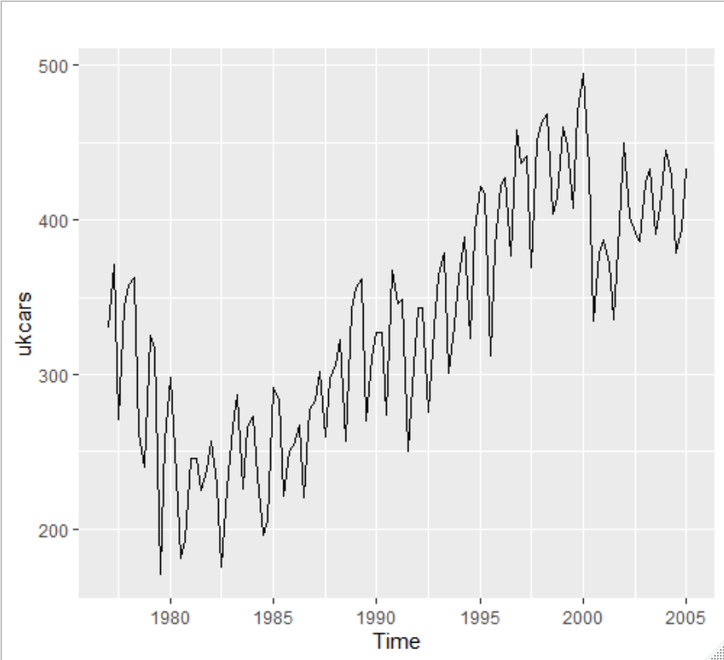
   1. The graph shows a dip in the number of cars in the UK around 1980 to roughly 1987. After about 1987 there is a steady upwards trend. There is a rather large amount of seasonality
2. 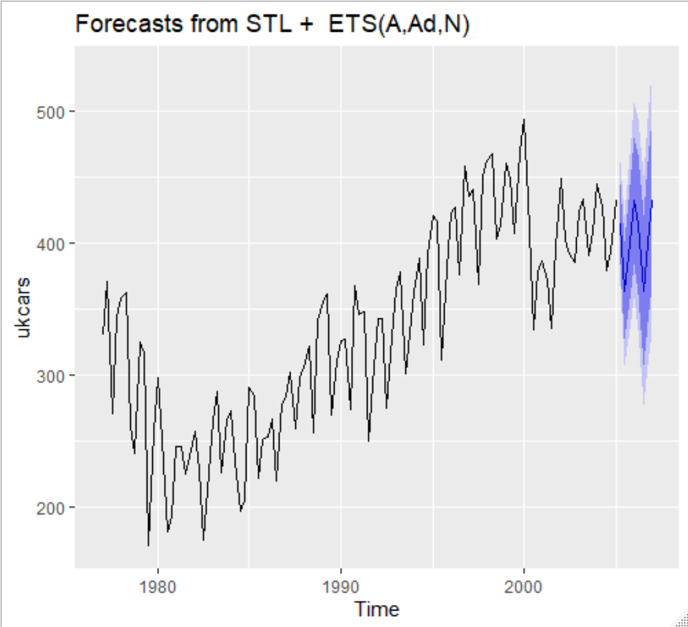
3. 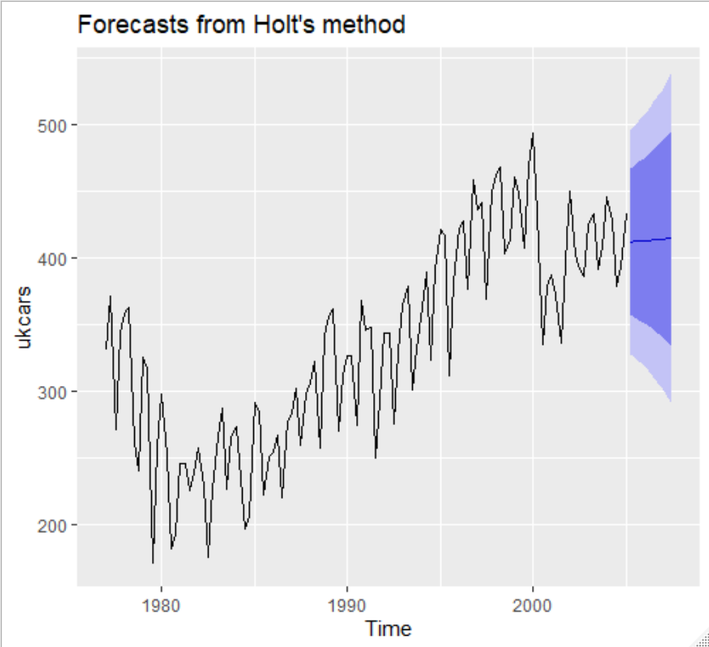
4. 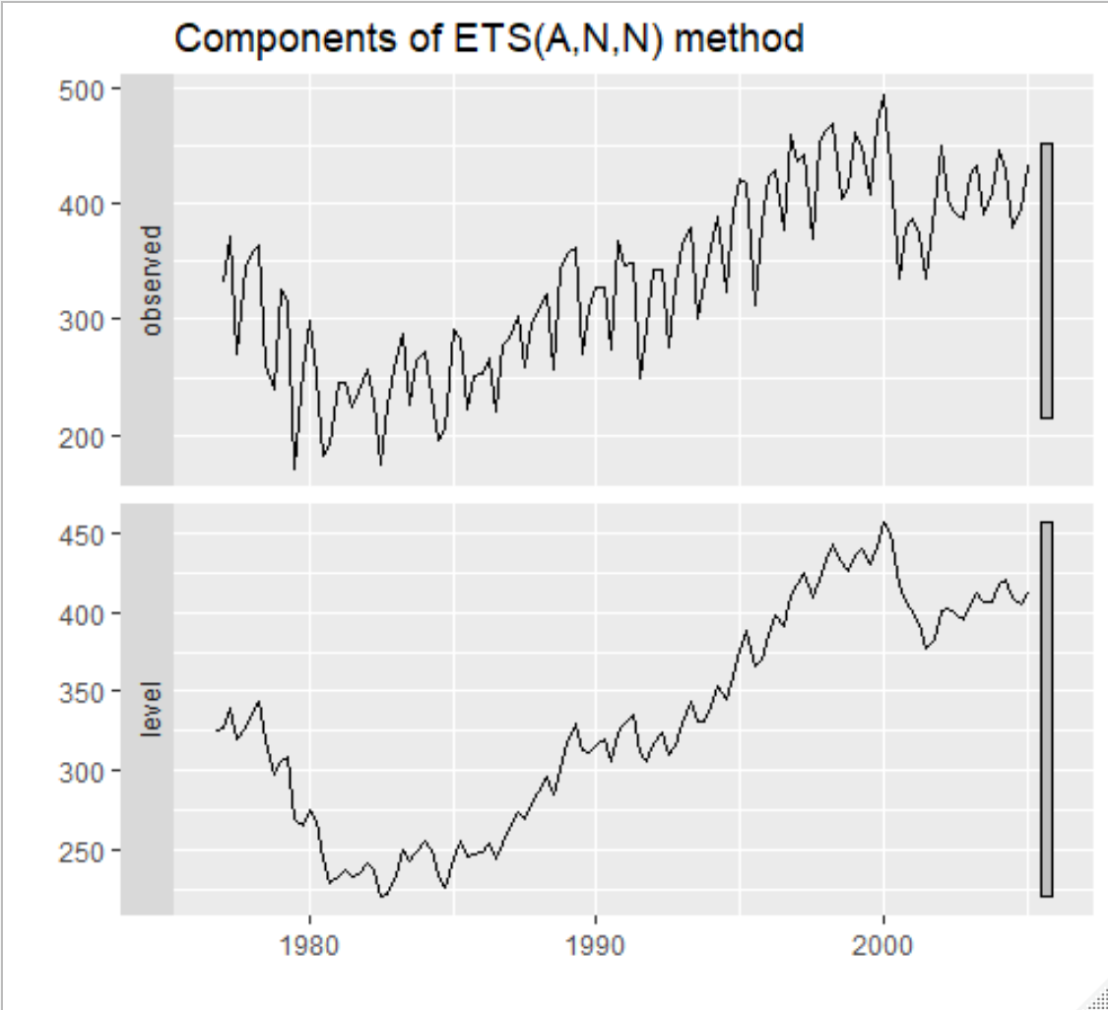
5. Based on the following RMSE values I chose the STL decomposition model as best fit
   1. STL RMSE – 23.32
   2. Holt RMSE – 42.17
   3. ETS RMSE – 42.1
6. The STL decomposition graph seems to be the most reasonable even before knowing the RMSE of each model. The forecast just fits right along with the seasonability of the rest of the graph
7. 